23-7-26 QUERY PROCESSING FOR DATA SCIENCE SIDDARTH.P
7.Write a Pandas program to create a Pivot table and find the maximum and minimum
sale value of the items.
Date | Open | High | Low | Close | Volume
2016-10-03 | 774.25 | 776.06 | 769.50 | 772.55 | 1500000
2016-10-04 | 776.03 | 778.71 | 772.89 | 776.42 | 1400000
2016-10-05 | 779.30 | 782.07 | 775.65 | 776.46 | 1300000
2016-10-06 | 779.00 | 780.47 | 775.53 | 776.85 | 1200000
2016-10-07 | 779.65 | 779.65 | 770.75 | 775.08 | 1100000

Code:
import pandas as pd
import matplotlib.pyplot as plt

df = pd.read_csv("alphabet_stock_data.csv", parse_dates=['Date'])

data = df[(df['Date'] >= '2016-10-03') & (df['Date'] <= '2016-10-07')]

plt.scatter(data['Volume'], data['Close'])
plt.xlabel("Volume")
plt.ylabel("Close Price")
plt.title("Volume vs Close Price")
plt.show()

Output:
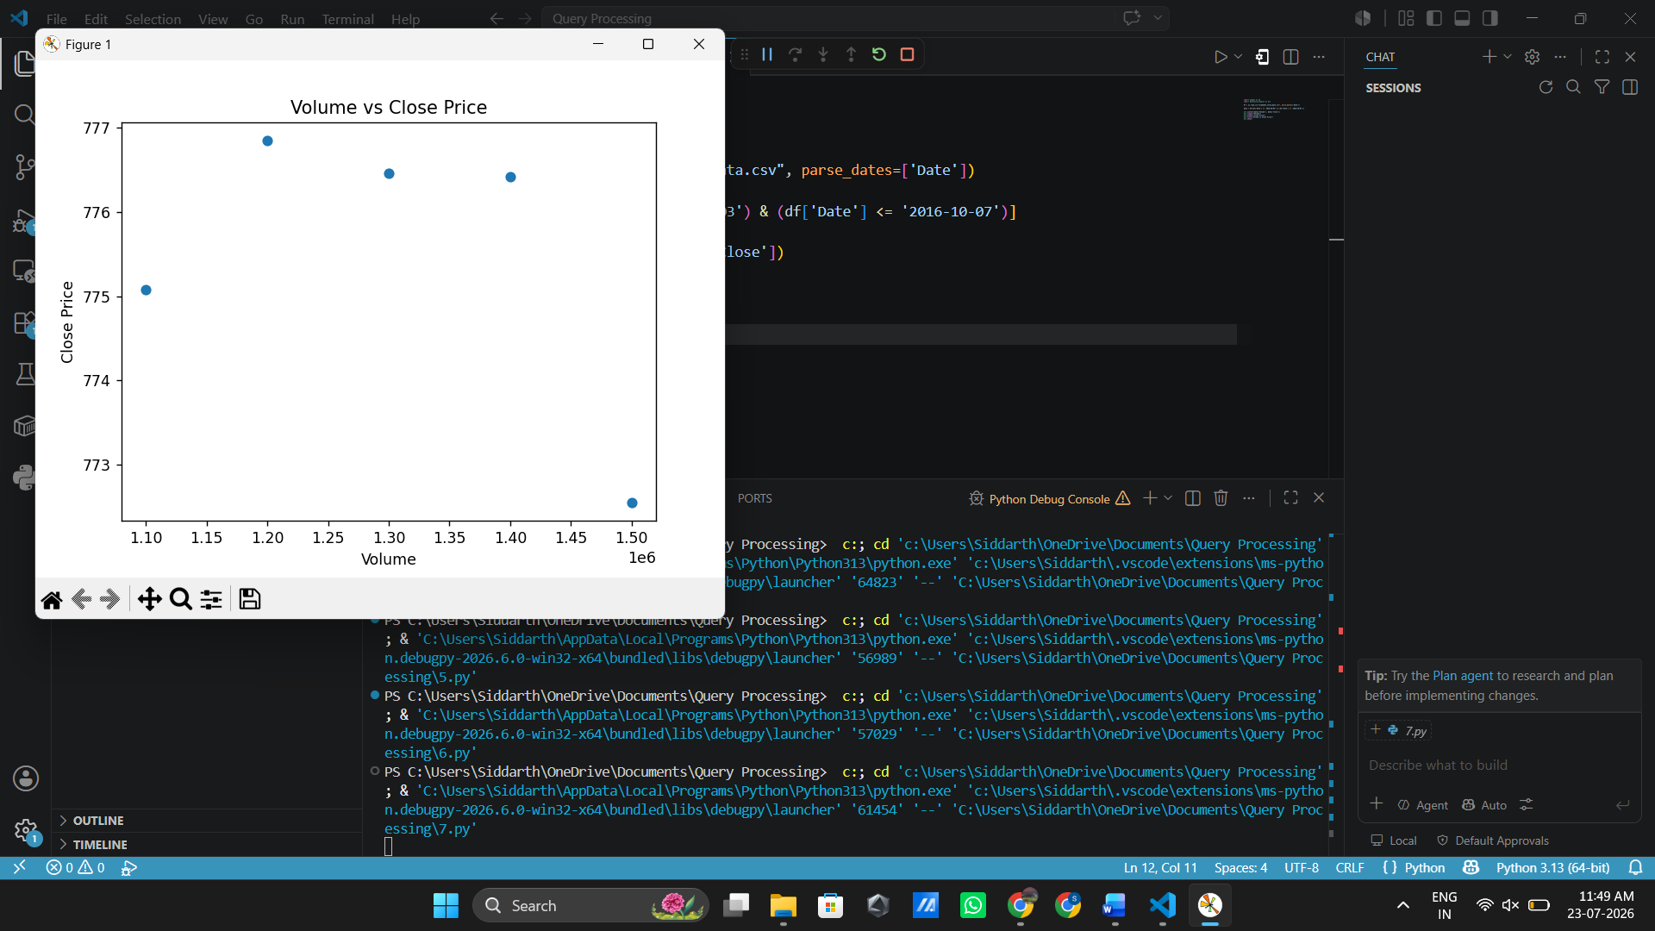

8.Write a Pandas program to create a Pivot table and find the item wise unit sold.
OrderDate | Region | Manager | SalesMan | Item | Units | Unit_price | Sale_amt
1-6-18 | East | Martha | Alexander | Television | 95 | 1198 | 113810
1-23-18 | Central | Hermann | Shelli | Home Theater | 50 | 500 | 25000
2-9-18 | Central | Hermann | Luis | Television | 36 | 1198 | 43128
3-15-18 | West | Timothy | Stephen | Television | 56 | 1198 | 67088
4-1-18 | East | Martha | Alexander | Home Theater | 60 | 500 | 30000

Code:
import pandas as pd
df = pd.read_csv("sales_data.csv")

pivot = pd.pivot_table(df,
values='Units',
index='Item',
aggfunc='sum')
print(pivot)

Output:
